Nexora CRM accounts and associations
Document 6 of the Nexora learning guides
Source snapshot 13 October 2026 at 17:12 UTC
Understand company records and the history linking people to organisations.

Recognise the screen and its scope
Open /relationships/accounts. CRM routes use port 3017; member routes use 3018; public website routes can use 3019. Brackets name a route parameter, not text to paste into a browser. Choose a real record or site id from the application.
This guide covers Account forms and general information; Contact to Account links; Start and end dates; Department job title classification and roles; Main and authorised contacts; Transfer and association history.
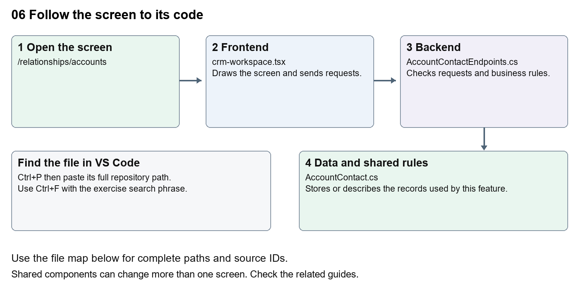
The diagram shows the file roles. The full paths below are what you paste into Ctrl+P.

Find the files in VS Code
Role | File and source ID | What it does
Screen | S0080 crm-workspace.tsx | Main UI or route for this topic
Server | S0239 AccountContactEndpoints.cs | Endpoints or server rules
Data | S0253 AccountContact.cs | Data shape or persistence structure

Screen S0080
apps/web/src/features/crm/crm-workspace.tsx
Server S0239
backend/src/Modules/Nexora.Modules.Crm/AccountContactEndpoints.cs
Data S0253
backend/src/Modules/Nexora.Modules.Crm/Domain/AccountContact.cs
The complete HTML manual opens these source IDs inside its Source library. The Word manual shows short labelled extracts so you can learn the flow before reading large files. Each individual Markdown guide includes its complete primary files after the walkthrough.

Follow the request and the records
1. The accounts route selects account as the record kind.
2. Opening an Account loads its saved detail.
3. The association panel asks for currently linked Contacts and optional history.
4. A link or change sends dates, role information and the expected version.
5. The backend checks tenant boundaries and preserves association history.

Read the code with an explanation
A Contact is a person and an Account is an organisation. Their association is a separate record, so a person can change organisation without rewriting their identity. Ending an association stores its end date. Authorised-contact flags describe the relationship, but explicit portal grants control member access to company data.
Source reference S0080 apps/web/src/features/crm/crm-workspace.tsx
Selected opening lines with their original numbers. The complete file is in the HTML source library.
0001 "use client";
0002 import styles from "./record-detail.module.css";
0003 import listingStyles from "./record-listing.module.css";
0004 import { RecordSection } from "./record-section";
0005 import { RecordTimeline } from "./record-timeline";
0006 import { RecordDataAudit } from "./record-data-audit";

The import lines lead to shared components and helpers. Start at the exported component or route function; follow the request helper to the server rather than assuming the whole feature lives in this file.
Source reference S0239 backend/src/Modules/Nexora.Modules.Crm/AccountContactEndpoints.cs
Extract from source line 17. A fragment from a long line is shown without the rest of that line.
0017 api.MapGet("/account-contact-options", () => new {

On the server, look for MapGet to load records, MapPost to create or perform an action, MapPut or MapPatch to change data, and RequireAuthorization for permissions. Some shared methods register endpoints indirectly. Find SaveChangesAsync to see the database write. A request method alone does not tell you every side effect.
Source reference S0253 backend/src/Modules/Nexora.Modules.Crm/Domain/AccountContact.cs
Selected opening lines with their original numbers. The complete file is in the HTML source library.
0001 namespace Nexora.Modules.Crm.Domain;
0003 // A person's association with an organisation; it is not a login or membership.
0004 public sealed class AccountContact : TenantRow
0005 {
0006 public Guid AccountId { get; set; }
0007 public Guid ContactId { get; set; }

Follow model fields to their request names and database mapping. An id points to a particular record. A tenant id limits the organisation. A version or concurrency stamp protects newer edits. Some model files describe contracts rather than tables; check the owning DbContext before assuming storage.

Make or trace your first change
1. Press Ctrl+P and open apps/web/src/features/crm/crm-workspace.tsx.
2. Press Ctrl+F and search for Account Name. In this snapshot it appears at line 107.
3. Replace this visible Account label only. Open the Account form and check the Contact form still uses its own label. Leave kind and the input name unchanged.
4. Replace only Account Name with Organisation name in that intended location. Keep quotes, tags, JSON keys and routes intact.
5. Save with Ctrl+S. Inspect Problems and the local screen. Review the diff and restore the original text when you finish practising.
Extract from source line 107. A fragment from a long line is shown without the rest of that line.
0107 <Label title={kind === "contact" ? "Label Name" : "Account Name"}><input className={input} name="name" defaultValue={row?.name} maxLength={160} required /></Label>

These exercises have not been applied to the application. Their search phrases are verified against the captured source. Line numbers can move; the phrase and file path are your main navigation aids.

Check a change and diagnose problems
Confirm the original screen still loads, the changed words appear in the intended place, and another screen using the same component still behaves correctly. If an action fails, inspect the browser Network response, the relevant helper and server validation message. Use the common error table at the beginning of the manual. Reload on a version conflict instead of removing the version check.
A syntax error after a text edit usually means a quote, brace or closing tag changed. Compare your diff with the original. An unchanged browser result can mean the wrong port, a saved published configuration overriding a default, or a running API that has not reloaded.

Understand the current limits
Do not assume an association grants portal access. Ending or transferring links has operational consequences; the beginner exercise changes wording only. Existing history must be preserved.

Continue learning
Related guides 05 Nexora CRM contacts, 08 Nexora record profiles and related information, 20 Nexora administration and access, 25 Nexora member portal journeys.

